SQL Assignment 7

Summarizing data with Aggregate Function.

Q1) Write a query that counts all orders for October 3.
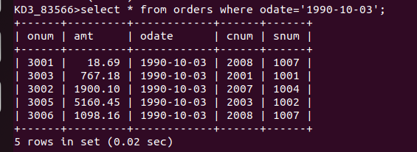

Q2) Write a query that counts the nymber of different non-null city values in the customers table.

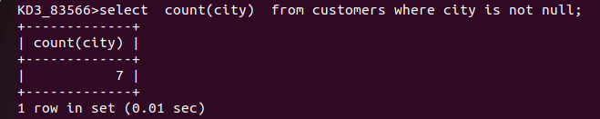

Q3) Write a query that selects each customers smalles order.

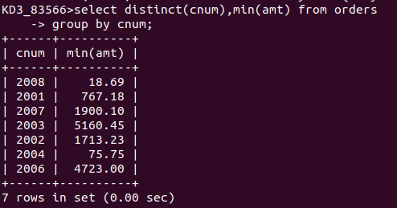

Q4) Write a query that selects the first customer, in alphabetical order, whose name begins with G.



Q5) Write a query that selects the highest rating in each city.

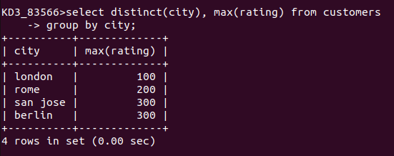
Q6) Write a query that counts the number of salespeople registering orders for each day . (If a salesperson has more than one order on a givenday, he or she should be counted only once.)

